How to Make a Shays’ Rebellion
Summary:
By the time the American Revolution ended in 1783, thousands of New England farmers served in the Continental Army under George Washington. During the course of their service, many veterans returned to their farms to find them in disrepair, or sometimes, no longer in existence at all.

In the mid 1780s, American states like Massachusetts found themselves owing considerable war monies to lenders in Europe. Faced with the pressure to pay back that money, plus retain their own power, Massachusetts creditors and government agents began seizing farms and property from farmers who could not pay their debts.

Many farmers rebelled against the government because they had not been paid for their service in the Continental Army, and therefore could not afford to pay their creditors. Plus, they wondered, why were they not being honored, instead of punished for their service to their new country?

As government agents tried to bring farmers to debtor’s court, leaders like Luke Day and Daniel Shays emerged to fight for farmers’ rights. Shays enlisted an army of over one thousand farmers and war veterans. Massachusetts argued his assembly was illegal under the Riot Act, but he protested anyway. He and his army battled the Massachusetts Militia for nearly two years, before most of his army disbanded or surrendered.

Shays and his top leaders were arrested and put on trial. General Lincoln, leader of the militia, asked for the men to be pardoned. Sam Adams argued against the pardons and many rebels were hanged. Shays was pardoned and lived the rest of his life in poverty. The rebellion scared the Founding Fathers so much that they decided a stronger federal government was necessary. The Constitution would be born out of Shays’ Rebellion.
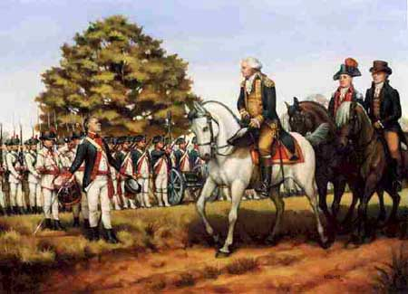

Time:
- Six years for preparation
- Two years for rebellion

Ingredients:
- Leftover Revolution
- Thousands of unpaid angry farmers and war veterans
- $millions in farm debts
- 1 cup of wealthy creditors
- A pinch of Massachusetts courts
- 1 tsp Luke Day
- 1 t. Daniel Shays
- A dash of Sam Adams
- 1 Riot Act
- A dash of General Benjamin Lincoln
- A smothering of Massachusetts Militia
- A touch of Thomas Jefferson
- A pinch of Henry Knox

Procedure
- Mix leftover Revolution with unpaid war vets
- Add $millions of farm debts with 1 cup wealthy creditors
- Add pinch of Massachusetts courts
- Stir together until farmers are battered
- Place batter in heat until Duke and Shays rise
- Add a dash of Sam Adams and his Riot Act
- Let simmer for a few months
- After a few months, Shays’ Rebellion should rise
- Smother with Massachusetts Militia and a dash of Lincoln
- Add a touch of TJ and a Pinch of Henry Knox
- Rebellion will fall, Constitution will rise
- Total cooking time: two years

